***RFID Based Employee Attendance System***

### ***Software Design Specification***

***Version 2.0***

***Revision History***

|  |  |  |  |
| --- | --- | --- | --- |
| **Date** | **Version** | **Description** | **Authors** |
| 7th April, 2015 | 1.0 | Synopsis | - Viraj Sahai |
| 14th April, 2015 | 2.0 | Synopsis | - Viraj Sahai |

***Preface***

This document presents the **Software Requirements Specification for RFID based employee attendance system**. The major sections of the document address the system decomposition by module and the overview of the procedure.

Section 2, Overview, gives a view of the whole system design including the constraints and the stake holders. This discussion includes a Use Case Diagram that depicts the entire system.

Section 3, Specification Requirements, goes into details about the expected functional and non-functional requirements that the end system should meet.

Section 4, Detailed Design Description, gives in depth insight about the overall design implementation procedures opted. It also shows the basic UI design of the final system.

***Table of Contents***

1. Introduction
   1. Purpose----------------------------------------------------------------------------------- 7
   2. Scope-------------------------------------------------------------------------------------- 7
   3. Definitions, Acronyms, Abbreviations--------------------------------------------- 7
   4. References-------------------------------------------------------------------------------- 8
   5. Tools Used-------------------------------------------------------------------------------- 8
   6. Technologies Used--------------------------------------------------------------------- 8
2. Overall Description
   1. Product Perspective------------------------------------------------------------------- 9
   2. Process Model-------------------------------------------------------------------------- 10
   3. Scheduling Diagrams------------------------------------------------------------------ 10
   4. Stake Holders--------------------------------------------------------------------------- 11
   5. User Characteristics-------------------------------------------------------------------- 12
   6. Constraints------------------------------------------------------------------------------- 13
   7. External Interface Requirements--------------------------------------------------- 13
   8. Use Case Diagram---------------------------------------------------------------------- 14
   9. Use Case Model Description--------------------------------------------------------- 15

1. Specific Requirements
   1. Functional Requirements------------------------------------------------------------- 21
   2. Non-functional Requirements------------------------------------------------------- 21
2. Detailed Design Description
   1. Data Flow Diagram---------------------------------------------------------------------- 20
   2. Activity Diagram------------------------------------------------------------------------- 21
   3. State Diagram---------------------------------------------------------------------------- 22
   4. ER Diagram-------------------------------------------------------------------------------- 23
   5. Class Diagram---------------------------------------------------------------------------- 24
   6. Sequence Diagram---------------------------------------------------------------------- 25
   7. Collaboration Diagram----------------------------------------------------------------- 26
   8. User Design Implementation--------------------------------------------------------- 27

***List of Figures***

Figure 1, Work Breakdown Structure------------------------------------------------------------------ 7

Figure 2, Gantt Chart-------------------------------------------------------------------------------------- 8

Figure 3, Timeline Chart---------------------------------------------------------------------------------- 8

Figure 4, Pert Chart---------------------------------------------------------------------------------------- 9

Figure 5, Use Case Diagram----------------------------------------------------------------------------- 12

Figure 6, Data Flow Diagram---------------------------------------------------------------------------- 20

Figure 7, Activity Diagram------------------------------------------------------------------------------- 21

Figure 8, State Diagram---------------------------------------------------------------------------------- 22

Figure 9, ER Diagram------------------------------------------------------------------------------------- 23

Figure 10, Class Diagram-------------------------------------------------------------------------------- 24

Figure 11, Sequence Diagram-------------------------------------------------------------------------- 25

Figure 12, Collaboration Diagram--------------------------------------------------------------------- 26

Figure 13, Hardware Design---------------------------------------------------------------------------- 27

Figure 14, Homepage Design--------------------------------------------------------------------------- 28

Figure 15, Login Design----------------------------------------------------------------------------------- 29

Figure 16, Sign-Up Design-------------------------------------------------------------------------------- 30

Figure 17, User Profile Home Design------------------------------------------------------------------ 31

Figure 18, Attendance Details Design----------------------------------------------------------------- 32

Figure 19, User Details Design-------------------------------------------------------------------------- 33

***List of Tables***

Table of Definition, Acronym and Abbreviation----------------------------------------------------- 7

Use Case Tables--------------------------------------------------------------------------------------------- 12-18

1. Introduction

With growing manpower in the industrial sector, both, e-based and otherwise, the need to track and maintain the employee attendance record grows critically. Also, such a system can help track relevant employee information efficiently.

These demands can be handled by the implementation of a computer aided employee tracking system.

* 1. Purpose

The objective of the project is to provide an **easy and effective way of employee tracking and attendance**. Moreover, the system extends to provide other essential features such as- salary calculation and a notification system for the employees that would provide necessary information as salaries, holidays etc.

* 1. Scope

The RFID based employee registration system is supposed to have the following features-

* Registration of employees.
* RFID attendance system.
* Employee attendance record tracking.
* Notification system (attendance, salaries etc.) through e-mail and SMS.
* Salary management system.
* Guest can view basic organization details.  
     
  1. Definitions, Acronyms, Abbreviations

|  |  |  |
| --- | --- | --- |
| **Abbreviation** | **Description** | **Purpose** |
| RFID | Radio Frequency Identification | Recognize employee and update attendance |

1.4 Tools Used  
The various tools used for developing the system-

* **Designing Tools-**
* *Microsoft Visio:* For designing the various scheduling charts.
* *Rational Rose :*For designing the use case diagram.

1.5Technologies Used

The following tools have been used to implement the project-

* *Arduino:* For designing the hardware interface.
* *HTML/CSS/PHP:* For web interface designing.

1. Overall Description
   1. Product Perspective

The RFID based employee attendance system is aimed at providing easy to operate and maintain employee attendance records. The records can be used to know how many days in the month, the employee took leave.

Thus, it would be useful in calculating the salary of the employee. Furthermore, the system is extended to provide a notification system about holidays, salary etc. through e-mail and SMS service. Also, the guests can use the system for viewing the organization’s basic details.

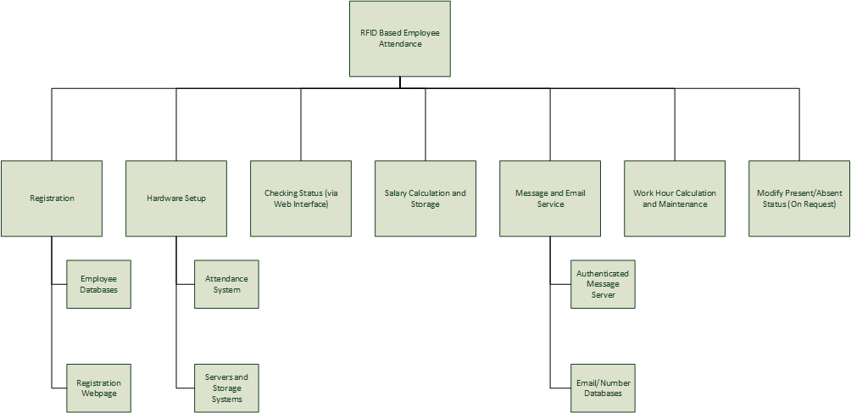

***Figure 1. Work Breakdown Structure***

* 1. Process Model

Because of the complications involved and a limited insight to the possible requirements the **exploratory model with throwaway prototyping** has been opted.

The version wise approach of the exploratory model makes it easier to tackle any intermediate requirement that might come into question, whereas such a flexibility is not available with other models such as waterfall. Moreover, the throwaway prototyping provides for step by step testing and analysis of every developed module and doesn’t even add to unnecessary complications like the spiral model.

* 1. Scheduling Diagrams
* **Gantt Chart**

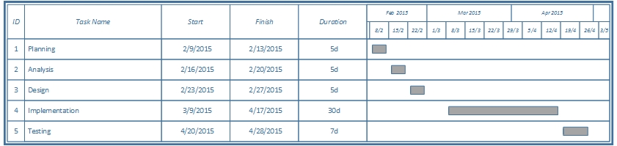

***Figure 2. Gantt Chart***

* **Timeline Chart**

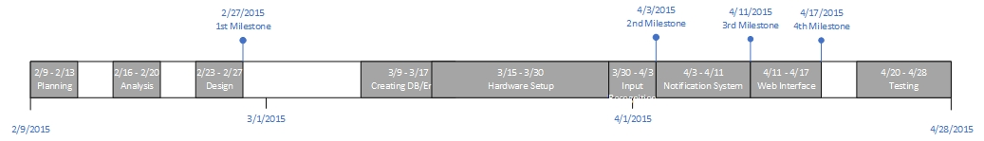

***Figure 3. Timeline Chart***

* **Pert Chart**

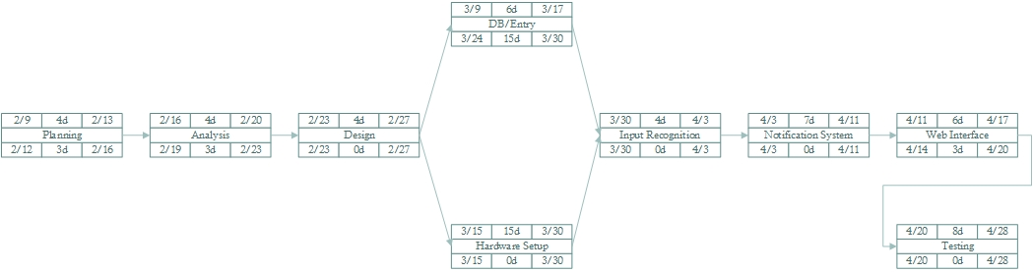

***Figure 4. Pert Chart***

* 1. Stake Holders

The product is implemented in such a way that it can be used by 4 categories of users-

* *Employees*
* *Operators*
* *Administrators*
* *Guests*
* **Employees**

The employees can use the system to mark their presence and also the number of hours worked every day, by punching the unique identification card in to the machine at the time of leaving. Also, the employees can keep a track of their attendance records and other details. The employees will be notified about various information, such as- holidays, salary etc., through e-mail and SMS services.

The employees can access their personal information by providing-

* Unique Login ID/Phone number.
* User created password.
* **Operators**

The operators would maintain the database and register employees to the system. Also, they will maintain and manage the **notification system** and post required messages. They can also update an employee’s attendance upon request from their managing head, in case, the employee forgets to mark their attendance. The operators can perform these tasks through their unique IDs.

* **Administrators**

The administrators maintain the security policies and manage the database design and access leverages. They can perform their duties through their unique login IDs.

* **Guests**

The organization guests can view the basic organization details. For this they do not need to provide any kind of details.

* 1. User Characteristics

The user interface and the online help shall be sufficient enough to get known to the new system. The operators and the employee, who are not at all familiar with such systems, can also make use of the available tutorials, end user training services and information for getting used to the system.

* 1. Constraints

The applicable constraints are-

* **Training the entire staff.**
* **Access load management.**
  1. External Interface Requirements
* **Hardware Interface**

The hardware interface would include-

* *Easy to use RFID attendance punching system.*
* *Easy to use GUI to view the organization details (for Guests).*
* **Software Interface**

The software interface would include-

* *Easy to use GUI.*
* *The details can be viewed using web browsers.*
* **Data Interface**

The data interface would include-

* *The system will have a login interface.*
* *The different types of users can access the data by using their respective login IDs.*
  1. Use Case Diagram

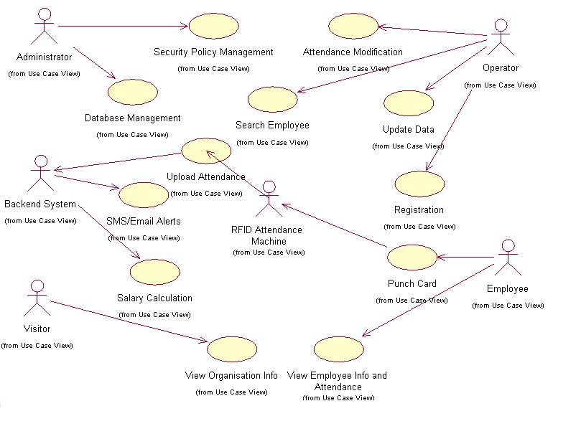

***Figure 5. Use Case Diagram***

* 1. Use Case Description

|  |  |  |
| --- | --- | --- |
| **Use Case ID** | 1 | |
| **Use Case Name** | Registration | |
| **Summary** | The system will be updated to hold the new entry which includes the details-   * Employee ID * Name * Address * Phone * Date of Birth * Gender | |
| **Precondition** | The operator registering the employee should also be registered | |
| **Success End Condition** | “Registration Successful” message displayed | |
| **Failed End Condition** | “Please fill in the required fields” message displayed | |
| **Primary, Secondary Actors** | Operator | |
| **Trigger** | This use case is initiated upon request from the employee for registration | |
| **Description** | **Step** |  |
|  | 1 | The end user clicks on the registration link |
|  | 2 | The end user fills in the required details from the employee |
|  | 3 | The end user clicks the “Submit” button once done |

|  |  |  |
| --- | --- | --- |
| **Use Case ID** | 2 | |
| **Use Case Name** | Update Data | |
| **Summary** | The system will be updated to the new details provided by the employee | |
| **Precondition** | - The operator updating the employee should also be authorized and registered  - The employee details should already be present | |
| **Success End Condition** | “Update Successful” message displayed | |
| **Failed End Condition** | “Update Failed. Invalid Data” message displayed | |
| **Primary, Secondary Actors** | Operator | |
| **Trigger** | This use case is initiated upon request from the employee for details update | |
| **Description** | **Step** |  |
|  | 1 | The end user clicks on the update link |
|  | 2 | The end user searches for the employee using name/ID |
|  | 3 | The end user fills in the required details from the employee |
|  | 4 | The end user clicks the “Submit” button once done |

|  |  |  |
| --- | --- | --- |
| **Use Case ID** | 3 | |
| **Use Case Name** | Attendance Modification | |
| **Summary** | The system will be altered to update the attendance records of the employee | |
| **Precondition** | - The operator registering the employee should also be authorized and registered  - The employee records should exist  - The employee must have an approved request from his/her managing head | |
| **Success End Condition** | “Update Successful” message displayed | |
| **Failed End Condition** | “Invalid Update” message displayed | |
| **Primary, Secondary Actors** | Operator | |
| **Trigger** | This use case is initiated upon request from the employee for attendance modification | |
| **Description** | **Step** |  |
|  | 1 | The end user clicks on the modify attendance link |
|  | 2 | The end user searches for the employee using name/ID |
|  | 3 | The end user updates the attendance of the employee |
|  | 4 | The end user clicks the “Submit” button once done |

|  |  |  |
| --- | --- | --- |
| **Use Case ID** | 4 | |
| **Use Case Name** | Search Employee | |
| **Summary** | The system will be searched for employees on a specific criteria | |
| **Precondition** | - The operator registering the employee should also be authorized and registered  - The search conditions should be valid | |
| **Success End Condition** | “Search Successful” message displayed and results are shown on screen | |
| **Failed End Condition** | “Invalid Search” message displayed | |
| **Primary, Secondary Actors** | Operator | |
| **Trigger** | This use case is initiated upon request from the managing head for some official purpose | |
| **Description** | **Step** |  |
|  | 1 | The end user clicks on the search link |
|  | 2 | The end user selects the criteria of search |
|  | 3 | The end user provides value for the search criteria |
|  | 4 | The end user fills in the required details from the employee |
|  | 5 | The end user clicks the “Submit” button once done |

|  |  |  |
| --- | --- | --- |
| **Use Case ID** | 5 | |
| **Use Case Name** | Security Policy Management | |
| **Summary** | The system’s access rights and other policies can be maintained, managed and modified | |
| **Precondition** | The administrator viewing and modifying the policies should also be authorized and registered | |
| **Success End Condition** | “Operation Successful” message displayed | |
| **Failed End Condition** | “Invalid Operation or User Unauthorized” message displayed | |
| **Primary, Secondary Actors** | Administrator | |
| **Trigger** | This use case is initiated when a security change is required | |
| **Description** | **Step** |  |
|  | 1 | The end user clicks on the admin login link |
|  | 2 | The end user performs the required tasks |
|  | 3 | The end user clicks the “Save” button once done |

|  |  |  |
| --- | --- | --- |
| **Use Case ID** | 6 | |
| **Use Case Name** | Database Management | |
| **Summary** | The system’s database schema and design can me managed and modified | |
| **Precondition** | The administrator managing the database should also be authorized and registered | |
| **Success End Condition** | “Database Modification Successful” message displayed | |
| **Failed End Condition** | “Invalid step. Constraints Violated” message displayed | |
| **Primary, Secondary Actors** | Administrator | |
| **Trigger** | This use case is initiated when the database schema needs to be managed or updated | |
| **Description** | **Step** |  |
|  | 1 | The end user clicks on the admin login link |
|  | 2 | The end user performs the required tasks |
|  | 3 | The end user clicks the “Save” button once done |

|  |  |  |
| --- | --- | --- |
| **Use Case ID** | 7 | |
| **Use Case Name** | Upload Attendance | |
| **Summary** | The RFID machine will upload attendance to the backend system | |
| **Precondition** | - The employee whose attendance is uploaded should be registered  - The punching time should be within office working hours constraints  - The backend system should be 100% working  - There should be no data update inconsistencies | |
| **Success End Condition** | “Thank You. Attendance Marked” message displayed | |
| **Failed End Condition** | “Please try again. Please make sure you are a registered user.” message displayed | |
| **Primary, Secondary Actors** | RFID attendance machine | |
| **Trigger** | This use case is initiated when an employee punches in his RFID card for attendance | |
| **Description** | **Step** |  |
|  | 1 | After the user has punched in the attendance card, the data line is checked to see if it’s active and if data can be sent |
|  | 2 | The particular employee will be searched for |
|  | 3 | The attendance will be uploaded |

|  |  |  |
| --- | --- | --- |
| **Use Case ID** | 8 | |
| **Use Case Name** | SMS/Email Alerts | |
| **Summary** | The system will send automatic e-mails/SMSs regarding information | |
| **Precondition** | - The email/SMS server should be working and authenticated  - The employee (or employees) to whom the mail/SMS is to be sent, should be registered | |
| **Success End Condition** | “Message Successfully Sent” message displayed | |
| **Failed End Condition** | “Error. Invalid address/number or Server error.” message displayed | |
| **Primary, Secondary Actors** | Backend System | |
| **Trigger** | This use case is initiated when some information is to be communicated to the employee | |
| **Description** | **Step** |  |
|  | 1 | The backed system will select the appropriate message regarding the situation |
|  | 2 | The message server status will be verified |
|  | 3 | The message will be sent |

|  |  |  |
| --- | --- | --- |
| **Use Case ID** | 9 | |
| **Use Case Name** | Salary Calculation | |
| **Summary** | The system will calculate the employees’ salaries | |
| **Precondition** | The employee’s working hour records should be present | |
| **Success End Condition** | After calculation the data would be stored in the database | |
| **Failed End Condition** | - “Unexpected Value” message will displayed  - “Database Inconsistent” message will be displayed | |
| **Primary, Secondary Actors** | Backend System | |
| **Trigger** | This use case is initiated monthly to calculate employees’ salaries | |
| **Description** | **Step** |  |
|  | 1 | The backend system reads attendance and working hours records |
|  | 2 | The salary for every employee is calculated |
|  | 3 | The salary is stored in another table corresponding to every employee’s entry |

|  |  |  |
| --- | --- | --- |
| **Use Case ID** | 10 | |
| **Use Case Name** | View Organization Information | |
| **Summary** | The system will show the basic organization details | |
| **Precondition** | - | |
| **Success End Condition** | Display organization details | |
| **Failed End Condition** | “System Down” message will be displayed | |
| **Primary, Secondary Actors** | Guest | |
| **Trigger** | This use case is initiated when the guest wants to view organization details | |
| **Description** | **Step** |  |
|  | 1 | The end user click on the view organization details |

|  |  |  |
| --- | --- | --- |
| **Use Case ID** | 11 | |
| **Use Case Name** | View Employee Information and Attendance | |
| **Summary** | The system will display the stored employee details and attendance records | |
| **Precondition** | The employee view the details should registered | |
| **Success End Condition** | Details and attendance will be displayed | |
| **Failed End Condition** | - “System Down” message will be displayed  - “Unauthorized User” message will be displayed | |
| **Primary, Secondary Actors** | Employee | |
| **Trigger** | This use case is initiated when the user wants to view his/her attendance and details | |
| **Description** | **Step** |  |
|  | 1 | The end user logs in to his account |
|  | 2 | The end user clicks on view details link |

|  |  |  |
| --- | --- | --- |
| **Use Case ID** | 12 | |
| **Use Case Name** | Punch Card | |
| **Summary** | The employee will punch card to mark his/her presence | |
| **Precondition** | - The employee punching the card should be registered  - The RFID machine should be working | |
| **Success End Condition** | The machine will forward upload request to the backend system | |
| **Failed End Condition** | “Please try again” message displayed | |
| **Primary, Secondary Actors** | Employee | |
| **Trigger** | This use case is initiated when employee punches card to mark his/her attendance | |
| **Description** | **Step** |  |
|  | 1 | The end user brings the card closer to the machine |
|  | 2 | The end user waits till the machine says “Thank You. Attendance Marked” |
| **Extension** | **Step** |  |
|  | 1 | The attendance is uploaded to the database |

1. Specific Requirements
   1. Functional Requirements

The expected functional requirements are:-

* Secure registration of employees in the office.
* Search employees based on different criteria.
* Setup the basic details of the organization such as- working hours, number of working days etc.
* Set the hierarchy of the organization
* Send automatic mails to employees regarding salaries, attendance, holidays etc.
* Send messages to mobiles regarding salaries, attendance, holidays etc.
* Employees must be able to view and update their details. Also, they should be able to view their attendance details.
* Visitors must be able to view the organization’s basic details.
  1. Non-functional Requirements

The expected non-functional requirements are:-

* Secure access of confidential user data.
* Round the clock availability.
* System design should be able to work efficiently during peak time.
* The system should be flexible enough for future extension.

1. Detailed Design Description
   1. Data Flow Diagram

Data flow diagram **represents the flow of data from one model to another** through its various processes.

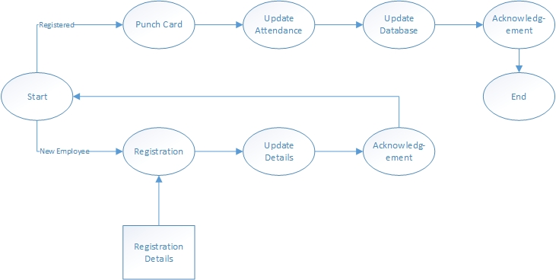

Attendance DB

User DB

***Figure 6. Data Flow Diagram***

* 1. Activity Diagram

Activity diagram **describes the activity flow throughout the execution** of the software from beginning to end. The activity flow encounters several conditional checks that redirect the path of activity to different state depending on the condition.

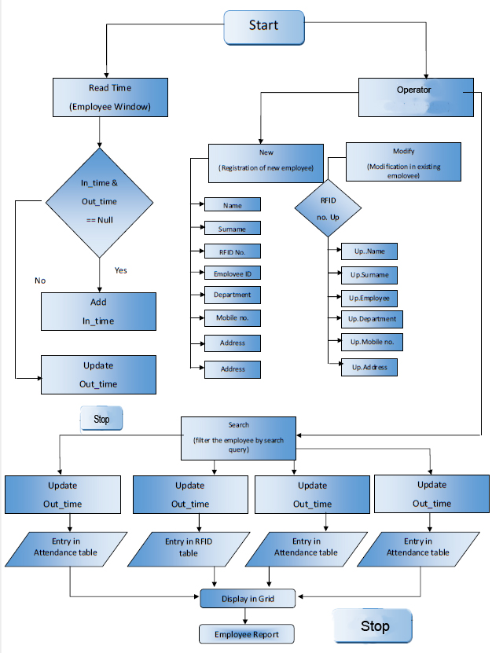

***Figure 7. Activity Diagram***

* 1. State Diagram

The **state diagram is similar to activity diagram** except the **activities in activity flow diagram is replaced by states** which are triggered by specific commands given by user or by computer to complete the task performed and reach the final state.

.

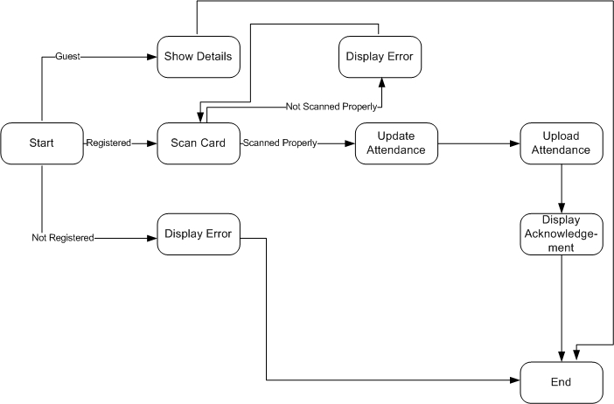

***Figure 8. State Diagram***

* 1. Class Diagram

The class diagram is an **extension of the ER diagram** with each entity being represented as a special class. Every **class contains a given set of attributes** to represent that entity and a **set of procedures** by which it intersects with other classes.

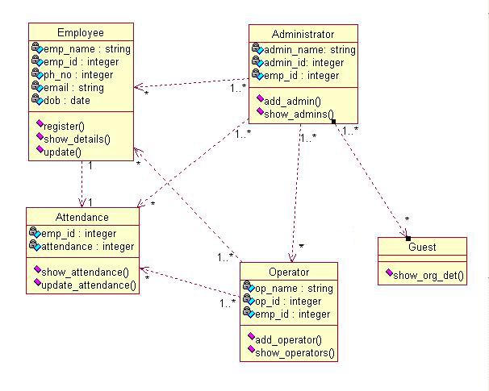

***Figure 10. Class Diagram***

* 1. Sequence Diagram

Sequence diagram **describes the series of procedure that must be followed** by every entity in the execution of the software.

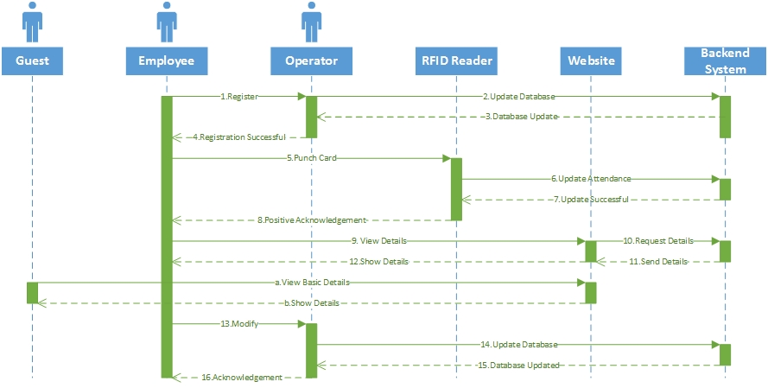

***Figure 11. Sequence Diagram***

* 1. Collaboration Diagram

Collaboration diagram is **a different representation of sequence diagram** which denotes the direction of cumulative procedure call between several entities present .However no specific sequence is mentioned.

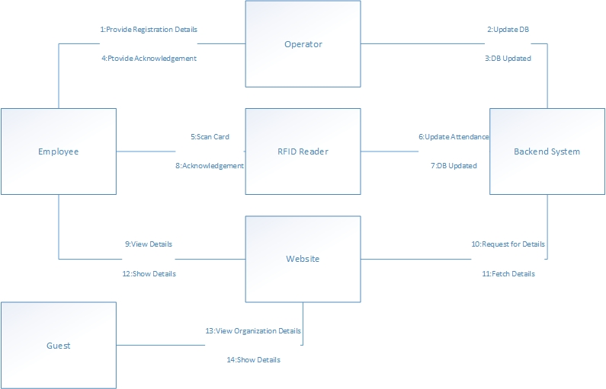

***Figure 12. Collaboration Diagram***

* 1. User Interface Implementation

User Interface, or UI, is basically **what the end user gets to see and deal with.** A good UI **ensures good customer experience** and, subsequent, **good feedback.**

* **Hardware Interface**

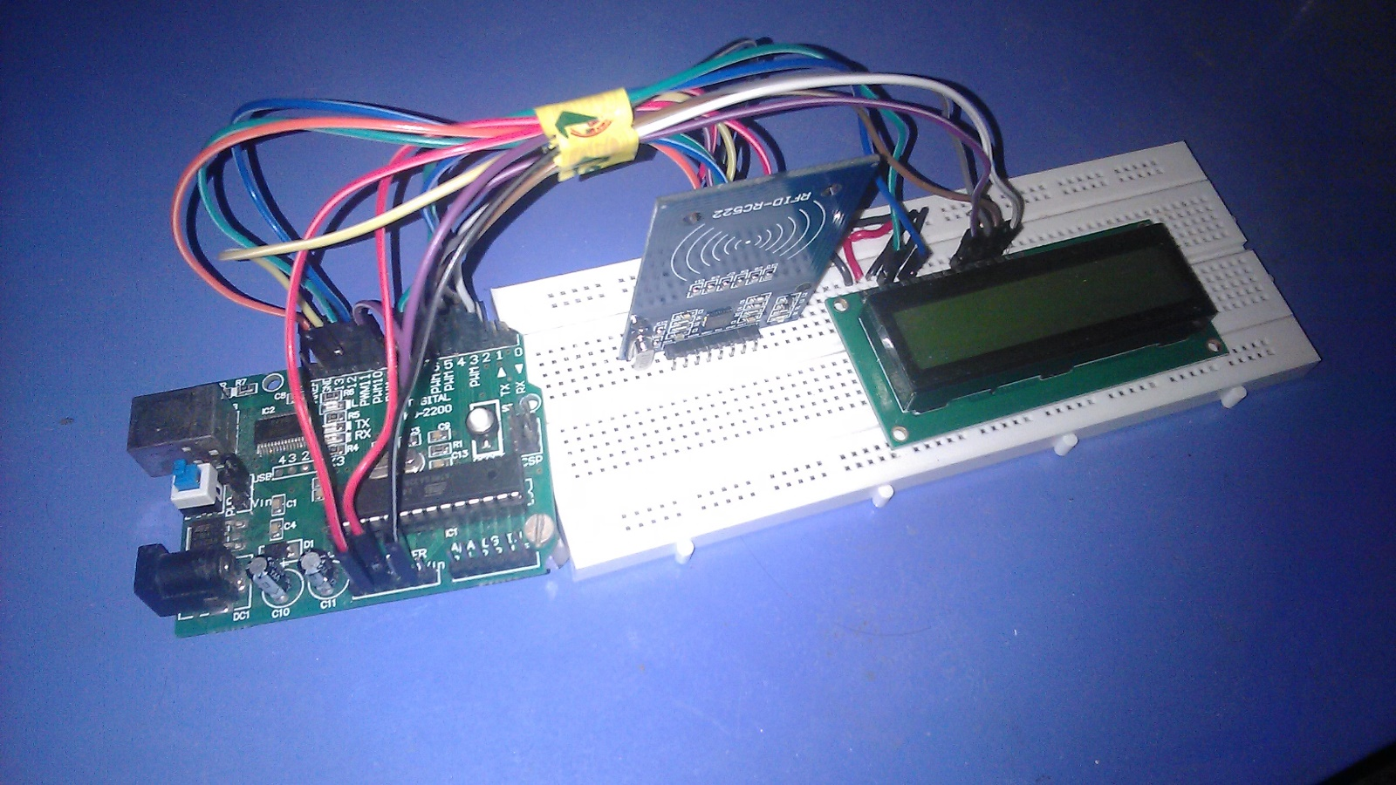

***Figure 13. Hardware Design***

* **Homepage**

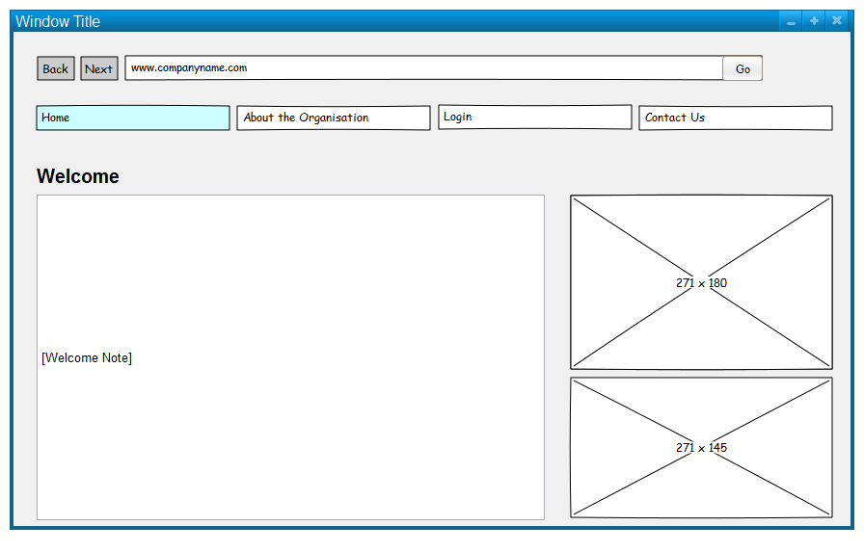

***Figure 14. Homepage Design***

* **Login**

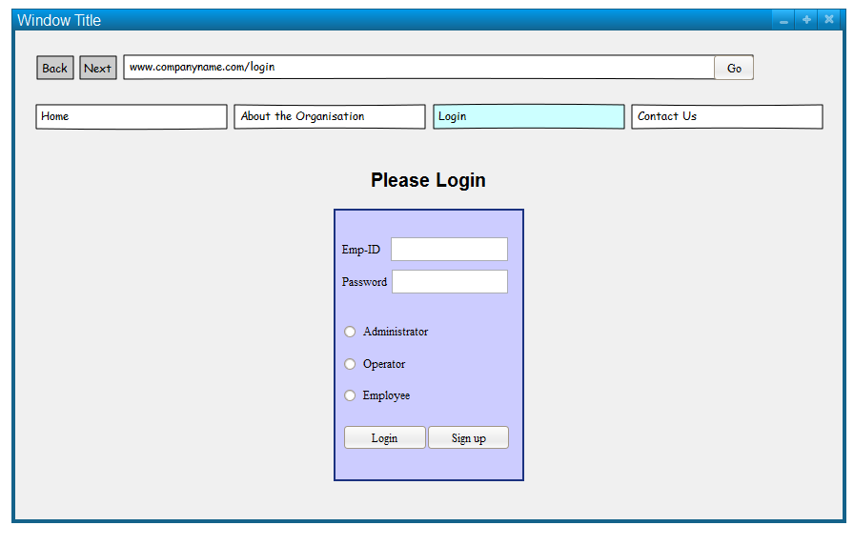

***Figure 15. Login Design***

* **Sign Up**

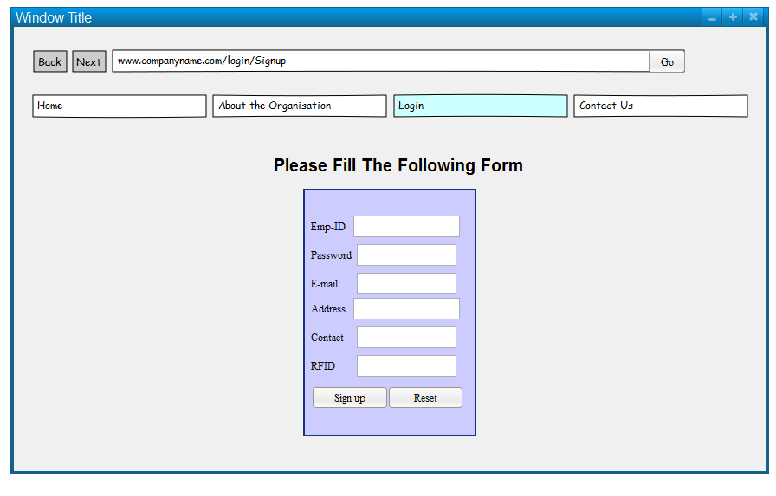

***Figure 16. Sign Up Design***

* **User Profile Home**

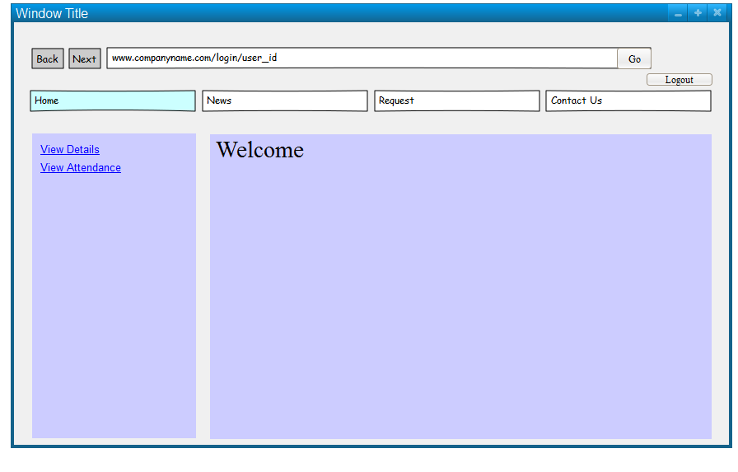

***Figure 17. User Home Design***

* **Show Attendance Details**

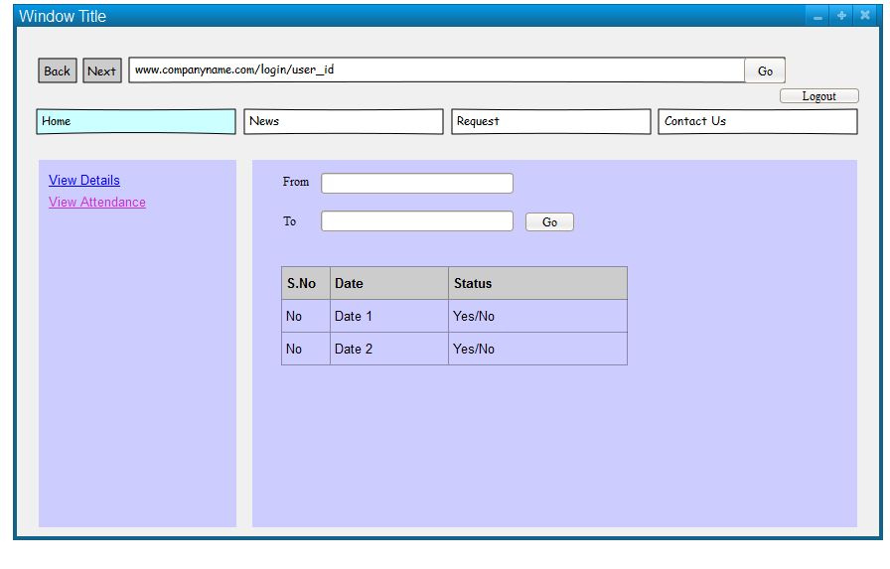

***Figure 18. Attendance Details Design***

* **Show User Details**

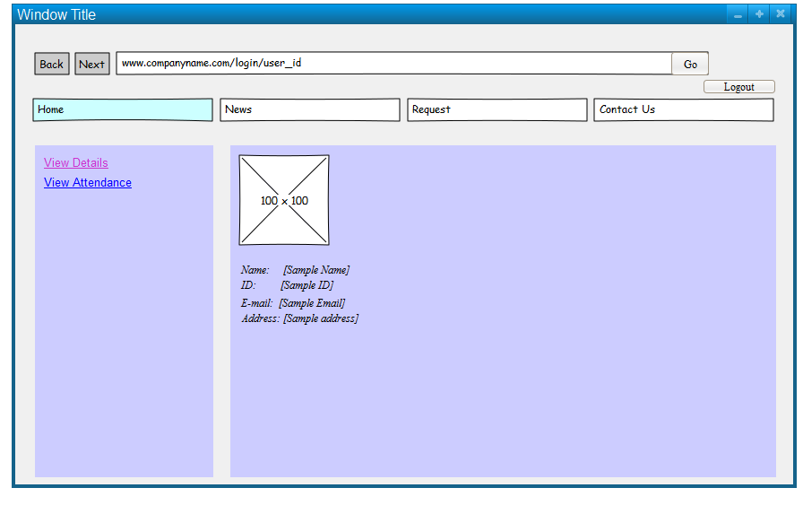

***Figure 19. User Details Design***